

- INVITATION -

1st & 2nd round of the
BMX EUROPEAN CHAMPIONSHIPS
&
European BMX Challenge

DIJON – MESSIGNY ET VANTOUX(FRANCE)

April 6th& 7th 2013





VENUE

DIJON – MESSIGNY ET VANTOUX

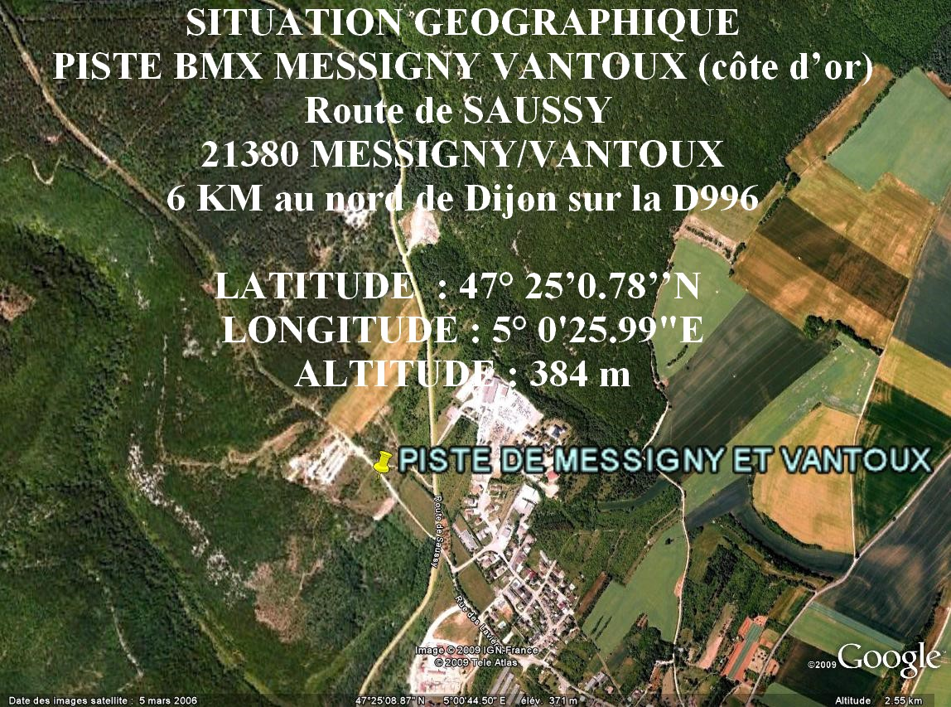

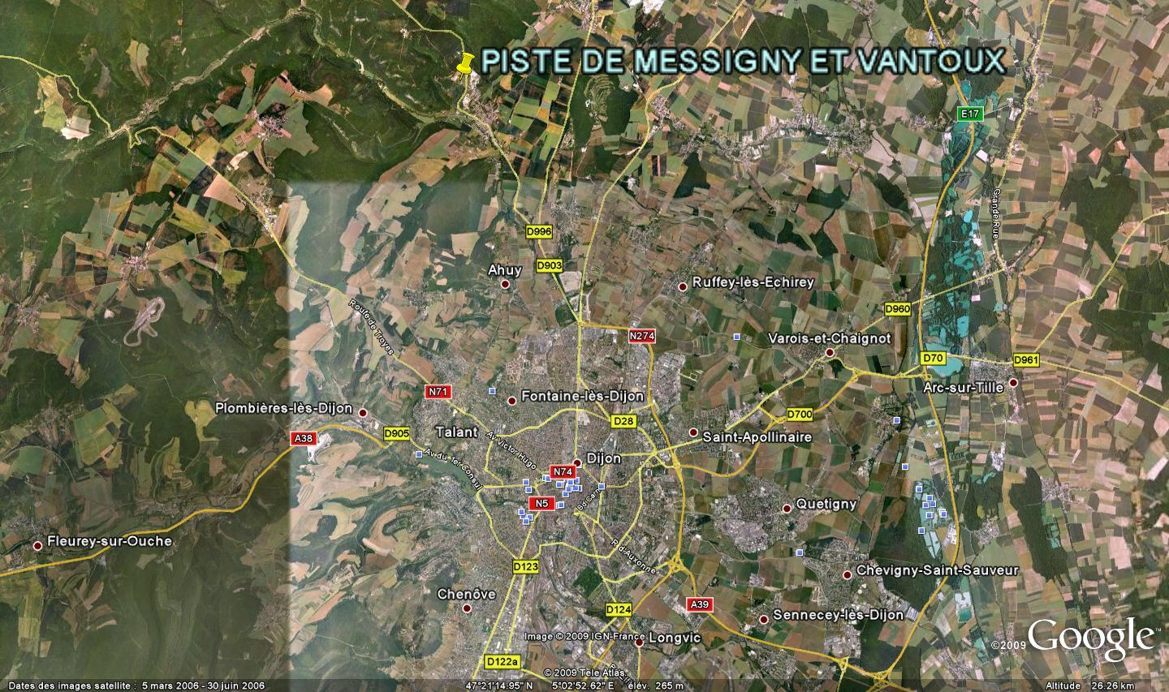

DATES & ESTIMATED TIMING (subject to changes according to number of entries)

- Thursday 4/04:

16:00 - 23:00 | OPENING OF WELCOME DESK FOR CAMPING

- Friday 5/04:

09:00-23:00 | OPENING OF WELCOME DESK FOR CAMPING
16:00 - 20:00 | WELCOME OF CHEFS D'EQUIPE - REGISTRATIONS CONTROL BY COUNTRY
16:00 - 18:00 | GATE PRACTICE FOR CHALLENGE CLASSES
18:00 - 18:45 | GATE PRACTICE FOR CRUISER CLASSES
18:45- 20:15 | GATE PRACTICE FOR CHAMPIONSHIP CLASSES (split)
19:00 | CHEFS D'EQUIPE MEETING (MANDATORY)

- Saturday 6/04:
08:00-20:00 | OPENING OF WELCOME DESK FOR CAMPING
08:00-09:00 | WELCOME DESK OPEN FOR LATE RIDERS
08:20-09:20 | GATE PRACTICE FOR GIRLS & BOYS 12 & - AND CRUISERS
09:30 | 3 MOTOS FOR GIRLS & BOYS 12 & - AND CRUISERS
12:45-13:00 | OPENING CEREMONY
13:00-14:00 | GATE PRACTICE FOR CHAMPIONSHIP CLASSES (split)
14:15-15:45 | 3 MOTOS FOR THE EUROPEAN CHAMPIONSHIP CLASSES
15:45 | 1/16; 1/8; 1/4; SEMIS & MAINS
18:00 | AWARD CEREMONY

- Sunday 7/04 :

08:00-09:15 | GATE PRACTICE FOR CHALLENGE CLASSES 13 AND OVER
09:20-12:00 | 3 MOTOS FOR CHALLENGE CLASSES
12:15-12:45 | GATE PRACTICE FOR CHAMPIONSHIP CLASSES (split)
13:00-14:30 | 1/16; 1/8; 1/4; SEMIS & MAINS
17:30-18:00 | AWARD CEREMONY

REGISTRATION DEADLINE

To be sent until March, 22nd 2013 by each Federation to:

René NICOLAS : bmx.europe@orange.fr

Late registrations are possible after this date but with a penalty of double fee.

Registration sheet herewith.

Registrations have to be paid by bank transfer to following bank account

IBAN : FR76 1076 8025 6800 0822 5854 582
BIC : CMCIFR2A
CCM DIJON THEATRE MIRANDE
63 RUE DE MIRANDE
21000 DIJON France

Account Owner

BMX VTT CLUB MESSIGNY et VANTOUX
14 RUE DE LA CHARRUE
21240 TALANT France

REGISTRATIONS FEE

Championship classes (per round) :

35 € Junior
57 € Elite

Challenge classes (per class) :

27 € (20” and 24”)

CLASSES

  - Championship Classes :

    - Women Junior / Men Junior
    - Women Elite / Men Elite

  - Challenge classes :

    - Girls 8 & -, 9/10, 11/12, Girls 13, Girls 14, Girls 15/16
Women 17+
    - Boys 8 &-, 9/10, 11/12, Boys 13, Boys 14, Boys 15/16
Men 17/24, Men 25/29, Masters (Men 30+)
    - Cruisers : 13/14, 15/16, 17/24, 25/29, 30/39, 40/44, 45+

REGISTRATION CONTROL

The registration control as well as the welcome of campers will be organized at:

SALLE des FETES of MESSIGNY et VANTOUX
Rue du STADE

Arrows will lead you to this place from the entry of the village.

Campers - Opening times :

Thursday 04/04/13 from 16H00 to 23H00
Friday 05/04/13 from 09H00 to 23H00
Saturday 06/04/13 from 08H00 to 20H00

See other information above

A complementary welcome desk will be installed on the track during Saturday and Sunday.

Riders - Pick up of documents: National Chef d’Equipe only

Date:Friday April 5th from 16:00 to 20:00

Each rider gets an envelope with one front plate and sideplate – Use of the organizers’ plate is mandatory.

PRIZE AND AWARDS

For all challenge classes: trophies for the 8 final riders of each category.

For all championship classes: trophies for the 3 first in final of each class and prize money as listed below.

 | ELITE MEN | ELITE WOMEN | JUNIOR MEN | JUNIOR WOMEN
PLACE | € / round | € / round | € / round | € / round
1 | 1 500 | 500 | 500 | 250
2 | 1 000 | 350 | 350 | 175
3 | 750 | 250 | 250 | 100
4 | 450 | 150 | 150 | 55
5 | 350 | 125 | 125 | 45
6 | 300 | 100 | 100 | 40
7 | 200 | 75 | 75 | 35
8 | 150 | 55 | 55 | 30
5th in 1/2 | 85 | - | 45 | -
6th in 1/2 | 75 | - | 40 | -
7th in 1/2 | 65 | - | 35 | -
8th in 1/2 | 55 | - | 30 | -

TEAMS AREA

Dedicated spaces are available for teams:

    - UEC registered teams
      - Trade
      - National
will have priority of space according to UEC rules
    - Other teams are welcome as well on the first come first served basis
    - Payment of a € 100.00 fee at arrival
    - Team area reservation form herewith : to be sent back to the organizer to the address indicated on reservation form.
www.bicross-club-messigny.com

FREE PUBLIC PARKING

Various free parking areas will be available next to the track. Arrows and various signs will lead you to the parkings.

No tent or motohome will be accepted on the parkings.

CAMPING

The camping area is situated next to the welcome center and offer all facilities: showers, toilets …..

Since the camping area is not next to the track the organization will offer a free shuttle service for people and bikes between the track and the camping.

Camping reservation forms to be sent back to the indicated address.

www.bicross-club-messigny.com

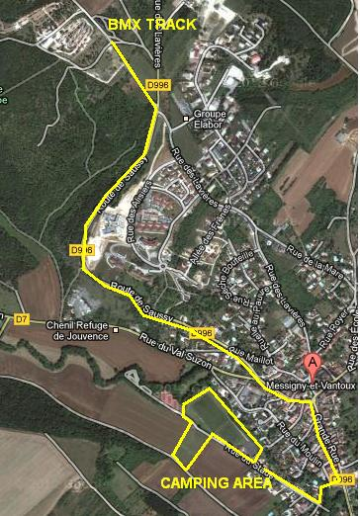

FOOD SERVICE

Everything willl be available around the track
Hot dishes
Hot and cold drinks
Pizzas
Local specialities…

VILLAGE

A shopping village will be installed on the track site with different shops

- Bike shops
- Regional food shops
- Exhibition stands of the sponsors

HOTELS

Hereafter list of hotels in the area nearby. We thank you to contact them in priority since they are all partners of the organization.

TEAM AREA RESERVATION FORM
- UEC REGISTERED TEAM
- TRADE TEAM
- NATIONAL TEAM

- NON REGISTERED TEAM

- NAME : ……………………………………………………………………………………………………………………………………………………..

- COUNTRY : ………………………………………………………………………………………………………………………………………………..

- TEAM MANAGER : …………………………………………………………………………………………………………………………………….

Welcome desk - Opening hours :

Thursday 04/04/13 From 16H00 to 23H00
Friday 05/04/13 From 09H00 to 23H00
Saturday 06/04/13 From 08H00 to 20H00

Thank you to let us know your estimated time of arrival :

- Thursday 04/04/13 …………………………………
- Friday 05/04/13 ………………………………...
- Saturday 06/04/13 …………………………………

Plate number of the car and the traylor:
…………………………………………………………………………………………………………………………………………………………….

Entry fee is € 100.00 per team.

Reservation sheet to send back to: bcmv.euro.team@gmail.com prior to 24/03/2013

Payment in cash at arrival

Registered UEC TEAMS will be placed as per UEC Rules.



CAMPING RESERVATION FORM
Country : ……………………………………………………….. …………………………………………………………………………………….
Name : ………………….……………………………………………………………………………………………………………………………….
  - Address : …………………………………………………………………………………………….
  - Zip Code : …………………………………………………………………………………………….
  - City : …………………………………………………………………………………………….
  - Phone + Mobile : …………………………………………………………………………………………….
  - E-mail : …………………………………………………………………………………………….

- CAMPING-CAR Quantity : …..... Véhicle length (only one vehicle per camping place)
- CARAVAN Quantity: …..... (only one vehicle per camping place)
- TENT Quantity: …..... (only one vehicle per camping place)
TOTAL : ....... (Entry fee is 50 € per camping place)

Overall amount due i.e. 50 € x ………. = …………………€

Opening hours :
Thursday 04/04/13 From 16H00 to 23H00
Friday 05/04/13 From 09H00 to 23H00
Saturday 06/04/13 From 08H00 to 20H00

Thank you to let us know your estimated time of arrival :
- Thursday 04/04/13 …………………………………
- Friday 05/04/13 ………………………………...
- Saturday 06/04/13 …………………………………

Plate number of the vehicle (s) :
…………………………………………………………………………………………………………………………………………………………….

If you wish to be positioned next to other people, all reservations will have to be sent together. _
An access campground pass will be given to you after your application has been accepted and payment has been received.. Notice: no access will be permitted without the proper campground access pass.

Reservation sheets are to be sent by email to : bcmv.euro.resa@gmail.com
Prior to March 24th 2013

Cash payment in €uros at the welcome desk at your arrival.

